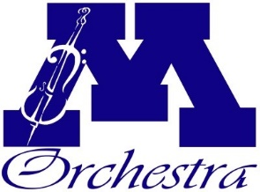
Scholarship Application Form
Minnetonka High School Orchestra

Scholarship Applying For:
Private Lessons

Student Name :__________________________ Student Email: _____________________________
Parent Name: ___________________________ Parent Email: ______________________________
Student Grade: ___________
How many years has the student participated in MHS Orchestra? ___________
Name of School and Music Teacher: _____________________________________________
Mailing Address of the School: _________________________________________________
Music teacher phone number: ________________________________________________________
Music teacher email address: _________________________________________________________
Are you requesting a FULL or PARTIAL Scholarship?
Full (weekly lessons for a semester) up to $500*
Partial (bi-weekly lessons for a semester) up to $300*
Total amount requested: ____________________________________________________
Students awarded a PARTIAL scholarship have no additional requirements to meet to be eligible, as this meets the lesson requirement for the program.

Students awarded a FULL scholarship will be required to give 5 volunteer hours to the Orchestra program.
Please initial here to indicate your understanding of this requirement. _____
All information is completely private and confidential. The only person with access to individual student application information is your student’s orchestra director
*any amount exceeding this limit requires Minnetonka Orchestra Board Booster approval.
Please submit this form with an invoice from your private teacher or school with the total amount, and the breakdown of price per lesson.

